

Essay / Assignment Title: Cloud-Based Big Data Analytics with Apache Spark and Hadoop Ecosystem

Programme title: MSC Data Analytics

Name: Prasad Naredla

Year: 2025

CONTENTS

CONTENTS I
LIST OF FIGURES III
LIST OF TABLES IV
1. INTRODUCTION 1
1.1. Purpose of the Assignment 1
1.2. Overview of Big Data in the Business Context 1
1.3. Importance of Cloud-Based Big Data Analytics 1
2. CHAPTER ONE: PROBLEM DEFINITION AND BUSINESS CONTEXT 3
2.1. Real-World Business Problem 3
2.2. The Need for Big Data Analytics 3
2.3. Business Value of Large-Scale Data Analytics 4
2.4. Dataset Selection and Justification 4
3. CHAPTER TWO: CLOUD ENVIRONMENT SETUP AND DATA INGESTION 6
3.1. Selection of Cloud Platform 6
3.2. Configuring the Big Data Processing Environment 6
3.3. Cluster Setup (Hadoop and Apache Spark) 7
3.4. Cluster UI Access 8
3.5. Dataset Upload to AWS S3 9
3.6. Data Ingestion Process 12
4. CHAPTER THREE: DATA PROCESSING WITH SPARK AND HADOOP 14
4.1. Hadoop MapReduce Job 14
4.1.1. Results 17
4.2. Apache Spark Data Processing 17
4.3. Comparative Analysis of MapReduce and Spark 20
4.4. Performance Evaluation and Insights 20
5. CHAPTER FOUR: ADVANCED ANALYTICS AND MACHINE LEARNING 22
5.1. Data Preprocessing and Feature Selection 22
5.1.1. Code for Data Preprocessing and Feature Selection 23
5.2. Model Selection and Training (Using Spark MLlib) 23
5.2.1. Code for Model Selection and Training 24
5.3. Evaluation of the Machine Learning Model 25
5.4. Visualization of Results 27
5.5. Business Insights and Recommendations 29
5.5.1. Business Recommendations 30
6. CHAPTER FIVE: CHALLENGES AND LIMITATIONS 31
6.1. Technical Challenges in Implementation 31
6.2. Limitations of the Dataset and Tools Used 31
7. CONCLUDING REMARKS 32
7.1. Summary of Findings 32
7.2. Recommendations for Future Work 32
BIBLIOGRAPHY 33
APPENDIX 35
Dataset 35
Colab Code Implementation 35
Tools Used 35

LIST OF FIGURES

Figure 1: Viewing EMR Cluster Configuration in JSON Format 8
Figure 2: URLs for Hadoop and Spark Web UIs on an EMR Cluster 9
Figure 3: Code snippet to load the flood insurance dataset into a Spark DataFrame. 11
Figure 4: Python code snippet to upload the dataset from Kaggle to AWS S3. 12
Figure 5: Creating an Input Directory in HDFS on an EMR Cluster 14
Figure 6: Hadoop DistCp Command for Data Transfer 15
Figure 7: Browsing the Hadoop Distributed File System via the NameNode UI 15
Figure 8: Python code snippet for MapReduce job using mrjob to calculate total insurance premiums by policy. 16
Figure 9: Word Count Results of ReportedCity Data Using MRJob 17
Figure 10: Python code snippet to process flood insurance data using Apache Spark and PySpark. 19
Figure 11: Data Preprocessing, Feature Selection, and StringIndexer Transformation for Categorical Column floodzone 23
Figure 12: Training a Random Forest Regression Model with PySpark 25
Figure 13: Calculating RMSE, MAE, and R-squared for a Regression Mode 26
Figure 14: Scatter Plot of Predicted vs. Actual Values in a Kenyan Regression Model 27
Figure 15: Visualizing Residuals to Assess Regression Model Performance 28
Figure 16: Visualizing Residual Distribution for Regression Diagnostics 29
Figure 17: Ranking Features by Importance in a Regression Model 30

LIST OF TABLES

Table 1: Key Differences between Hadoop and Spark for Data Processing 20

Statement of compliance with academic ethics and the avoidance of plagiarism

I honestly declare that this dissertation is entirely my own work and none of its part has been copied from printed or electronic sources, translated from foreign sources and reproduced from essays of other researchers or students. Wherever I have been based on ideas or other people texts I clearly declare it through the good use of references following academic ethics.
(In the case that is proved that part of the essay does not constitute an original work, but a copy of an already published essay or from another source, the student will be expelled permanently from the postgraduate program).

Name and Surname (Capital letters):
PRASAD NAREDLA
.......................................................................................................................................

Date: .01/02/2025

INTRODUCTION

Purpose of the Assignment
Big data analysis requires investigation through this project which specifically examines cloud-based platforms used for working with large datasets (Liang et al., 2023). This assignment demonstrates how advance big data tools Hadoop and MapReduce and methodologies address actual business challenges through integrated implementation (Varshavardhini, and Rajesh, 2023). The goal of using big data analytics methods produces insights that aid in process optimization and enhances both business decision quality and organizational results.

Overview of Big Data in the Business Context
The modern business landscape increasingly depends upon big data as a key business asset which enables companies to extract useful insights from both structured and unstructured quantities of information (Paramesha, Rane, and Rane, 2024). Business organizations utilize big data to fuel innovation through supply-chain optimization while understanding customers better and creating individualized experiences. The explosive growth of information from multiple sources including social media alongside IoT devices and e-commerce platforms demands sophisticated storage tools alongside analytic processing capabilities. The effectiveness of big data functioning enables organizations to survive competitive market environments by adjusting their strategies to evolving industry patterns.

Importance of Cloud-Based Big Data Analytics
Large data processing challenges receive vital solution through cloud-based big data analytics. Cloud technology provides scalable systems combined with flexible arrangements and economic benefits which allow organizations to conduct immediate data processing without needing substantial on-site hardware investments (Bello et al., 2021). Cloud environments deliver native integration with data-intensive tools Hadoop and Spark and MLlib as these tools streamline the execution of complicated analytical tasks. Modern businesses can use cloud-based analytics to boost collaboration along with quick data-driven decision making through strengthened data security and guaranteed availability which establishes this technology as a fundamental business tool.

CHAPTER ONE: PROBLEM DEFINITION AND BUSINESS CONTEXT

Real-World Business Problem
Extreme weather events attributable to climate change together with rising urbanization in vulnerable zones lead to sustained economic losses throughout America. Through the Federal Emergency Management Agency's National Flood Insurance Program (NFIP) homeowners and business owners receive financial protection against flood damage (Gray, 2024). The National Flood Insurance Program faces ongoing obstacles in policy productivity alongside pricing strategy problems and risk prediction difficulties. A data-driven method must be developed to address flood insurance challenges because accessible and affordable coverage standards require improvement.
This comprehensive policy database maintained by FEMA’s National Flood Insurance Policy Database exceeds 50 million individual policy transactions thus enabling detailed analysis for both insurance optimization and risk evaluation and region-specific customer solutions.

The Need for Big Data Analytics
Big Data Analytics demonstrates effectiveness for FEMA along with its partner organizations to handle large volumes of both structured and unstructured information with great efficiency (Vemprala, 2021). The insurance industry, particularly flood insurance, relies on data analytics to:
- Predictive models help underwriters develop better policies together with optimized pricing strategies.
- Spatial and census data help organizations evaluate demographic and geographic risk distribution.
- By analyzing claims patterns and coverage lapse data organizations can enhance their resource management strategy.
- Usage of historical data enables better decision quality through the development of implementable insights.
Empowered by Big Data Analytics, government entities can access vital patterns and trends to help FEMA achieve its essential mission of supporting flooding-related economic and social objectives.

Business Value of Large-Scale Data Analytics
The application of data analytics to FEMA's National Flood Insurance Policy Database can deliver the following business value:
- Risk Mitigation: Insurance companies using claims data and historical policy information generate superior flood risk prediction models to protect exposed regions better.
- Cost Optimization: Through advanced analytics methods FEMA tracks policy inefficiencies in pricing structures and claims management and resource distribution which lead to decreased operational expenditures.
- Customer Satisfaction: Insurers obtain insight into their customer base demographics and requirements which help them create custom tailored insurance products with easy accessibility.
- Policy Expansion: Analytics allows FEMA to enhance policy acceptance among underutilized communities and bolster regionally based flood resilience by finding underserved areas.
The insurance system must achieve sustainability through efficiency to reduce losses for population teams and communities alongside maintaining FEMA and private insurers' economic operational capability.

Dataset Selection and Justification
An analysis of FEMA's National Flood Insurance Policy Database obtained from Kaggle serves as the primary dataset. This dataset contains more than 50 million anonymized transactions, including detailed information on:
- The database maintains both flood zone classifications in addition to information about building elevation points.
- The dataset includes geographic identifiers that consist of zip codes and census tracts.
- Building and business types.
- Insurance coverage, premiums, and deductibles.
- Historical policy cancellations and ratings.
This dataset creates an optimal solution for our problem because it contains detailed information required for flood risk assessment combined with policy change analytics alongside demographic customer profiling data. The public domain licensing together with quarterly updates allows this dataset to ensure both ethical compliance and current relevant insights. This analysis uses the available dataset to develop effective recommendations which support FEMA's mission to protect community well-being through financial stability while dealing with rising flood hazards.

CHAPTER TWO: CLOUD ENVIRONMENT SETUP AND DATA INGESTION

This section will investigate the selection and configuration of the cloud platform before establishing the big data processing environment and performing cluster setup for Hadoop and Apache Spark. Data ingestion and AWS S3 upload procedures will then follow. The selection of cloud infrastructure centers on AWS which utilizes Amazon EMR to process big data utilizing Hadoop and Apache Spark (Mishra, 2022).

Selection of Cloud Platform
Amazon Web Services (AWS) functions as the chosen cloud platform for this project. The AWS cloud solution delivers big data applications by offering flexibility and protection while maintaining affordable operational costs. Through the platform's infrastructure users can leverage S3 storage solutions alongside the EMR execution engine for distributed data processing using Hadoop as well as Spark and additional big data frameworks.

Configuring the Big Data Processing Environment
The big data environment setup depends on Amazon EMR as our main software solution. Big data processing becomes simpler through Amazon EMR by delivering pre-packaged cluster arrangements (Manvi, and Shyam, 2021). The following setup will be used:
- Cluster Type: The configuration includes:
- The big data environment needs Amazon EMR for configurations where the main node runs m5.xlarge with 4 vCPUs and 16 GB memory but relies solely on EBS storage.
- The big data environment uses two Core Nodes (m5.xlarge) with 4 vCPUs, 16 GB memory, EBS-only storage each.
- A cluster includes one Task Node running m5.xlarge with EBS-only storage and 4 vCPUs alongside 16 GB of memory.
- Applications Installed:
- Hadoop 3.4.0
- Hive 3.1.3
- JupyterHub, Livy, Spark 3.5.3 for interactive sessions
A preconfigured AWS Glue Catalog serves to connect Hive metadata into a unified schema.
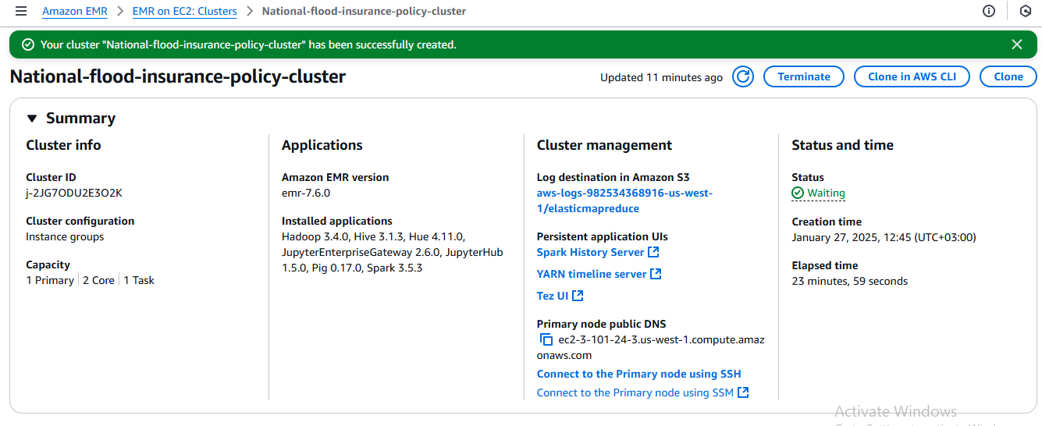

Cluster Setup (Hadoop and Apache Spark)
Amazon EMR organizes the cluster creation according to the specified configuration information. Such configuration offers strong capabilities for big data processing needs (Mahmoudian et al., 2023). The following EMR version is used:
- EMR Version: emr-7.6.0
- Applications: Hadoop 3.4.0, Hive 3.1.3, JupyterHub 1.5.0, Spark 3.5.3
Here is the configuration snippet that specifies the cluster settings for applications such as Spark and Hive:
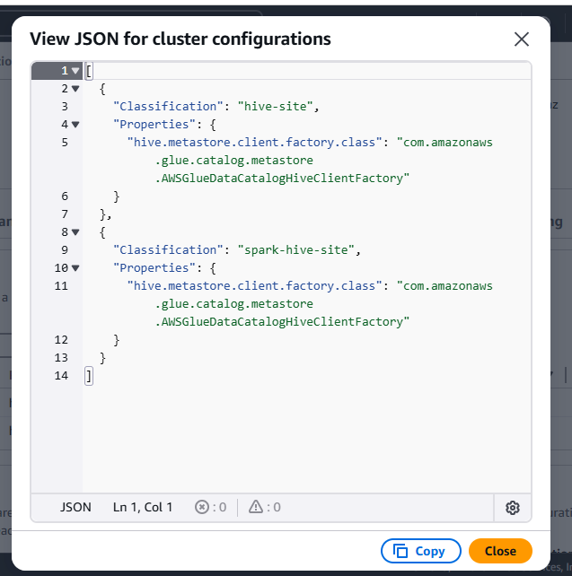
Figure 1: Viewing EMR Cluster Configuration in JSON Format

Cluster UI Access
A single primary node of the EMR cluster generates various application user interfaces accessible through HDFS JupyterHub and Spark History Server and additional tools. The cluster's user interfaces let users interact directly with the cluster infrastructure through job monitoring capabilities. Below are the links to key application UIs:
- HDFS Name Node: http://ec2-35-171-18-11.compute-1.amazonaws.com:9870/
- JupyterHub: https://ec2-35-171-18-11.compute-1.amazonaws.com:9443/
- Livy: http://ec2-35-171-18-11.compute-1.amazonaws.com:8998/
- Spark History Server: http://ec2-35-171-18-11.compute-1.amazonaws.com:18080/
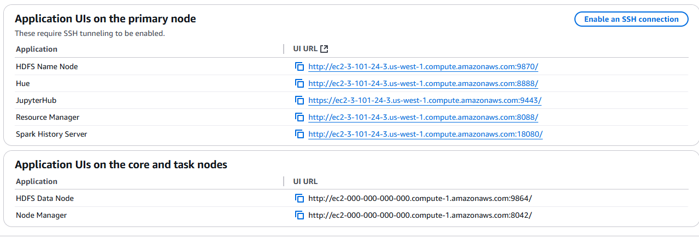
Figure 2: URLs for Hadoop and Spark Web UIs on an EMR Cluster

Dataset Upload to AWS S3
A Python script is needed to transport the dataset from Kaggle storage into an AWS S3 bucket. Nfip-flood-policies.csv represents the National Flood Insurance Program (NFIP) dataset which serves as the primary data collection.
- First, the Spark session is created to load the dataset:
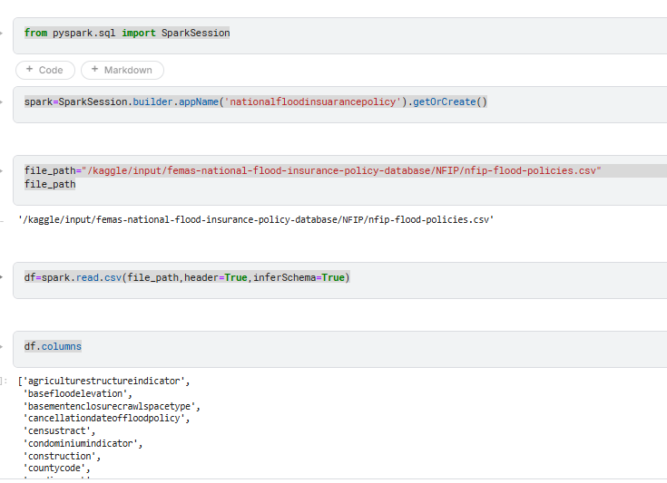
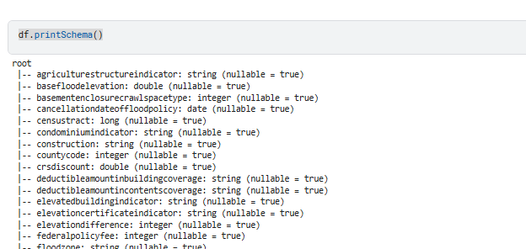
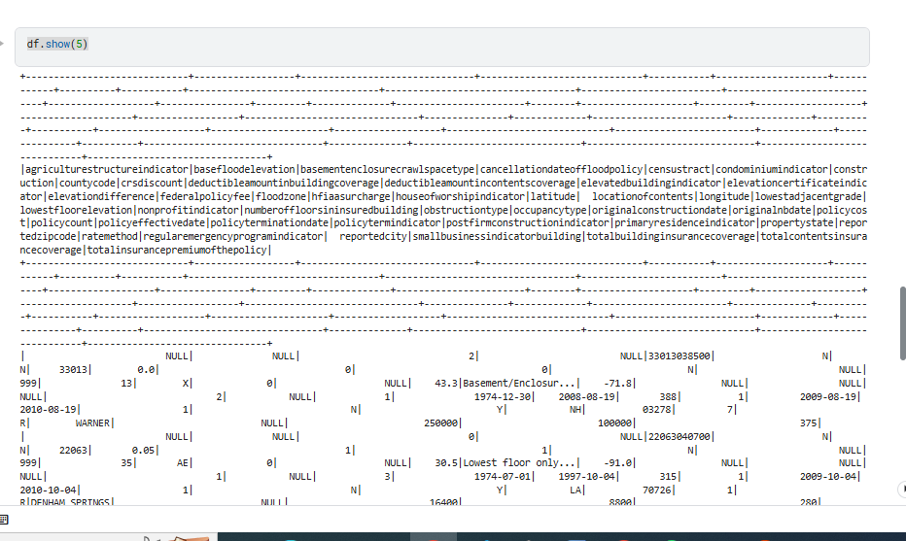
Figure 3: Code snippet to load the flood insurance dataset into a Spark DataFrame.
- After loading the data into Spark, it is uploaded to AWS S3 using Boto3, the AWS SDK for Python:
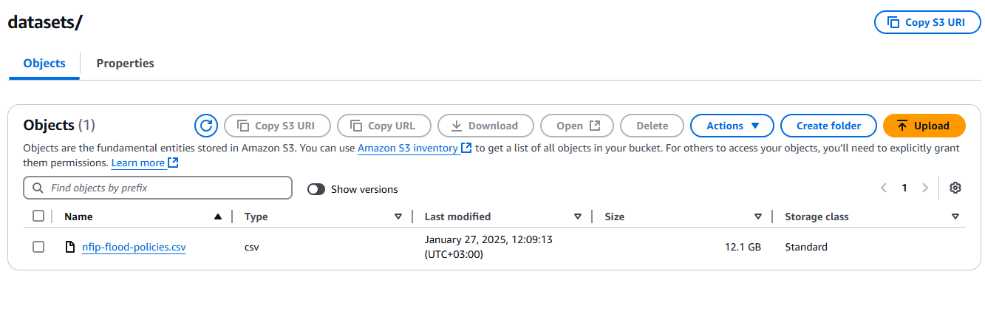
Figure 4: Python code snippet to upload the dataset from Kaggle to AWS S3.

Data Ingestion Process
The dataset moves to AWS S3 after upload where EMR cluster performs the necessary data processing tasks. Arrays of datasets store on the AWS S3 bucket act as the main data repository while tools including Spark or Hive serve to handle processing operations on the cluster. The following steps are typically followed:
- Connecting to the S3 bucket: Spark and Hive can access data located directly in S3 storage.
- Processing the Data: Cloud-based big data processing uses Spark jobs for executing data transformations together with aggregations and processing operations.
- Storing Results: Data processing results can be saved either to HDFS storage or returned to the S3 system pending the project specifications.
- Using Spark on Amazon EMR the system enables efficient handling of large datasets through scalable computing solutions.

CHAPTER THREE: DATA PROCESSING WITH SPARK AND HADOOP

Both Hadoop MapReduce and Apache Spark will be evaluated for their data processing functionality before a full comparison of these two technologies follows. This part will present performance evaluations and task processing insights along with performance evaluations of the assigned tasks.

Hadoop MapReduce Job
The programming model Hadoop MapReduce serves distributed environments to process massive data collections (Varshavardhini, S. and Rajesh, A., 2023). It divides the task into two main phases: Map and Reduce. During map tasks the framework distributes data into several pieces and then merge and consolidate the map results through reduce jobs.
When performing MapReduce jobs in Hadoop users must utilize the mrjob Python package. Through the mrjob package developers can easily produce MapReduce jobs in Python which operate either on local systems or Hadoop clusters. Below is an example of a MapReduce job using the mrjob package to process the flood insurance policy dataset:
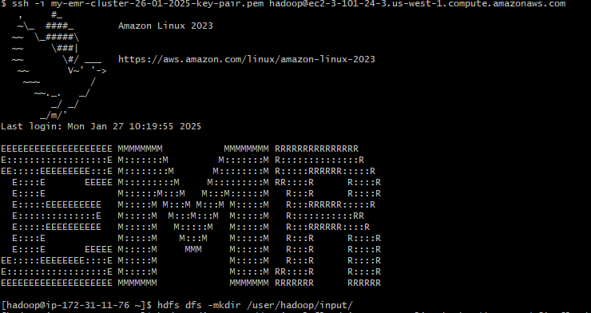
Figure 5: Creating an Input Directory in HDFS on an EMR Cluster
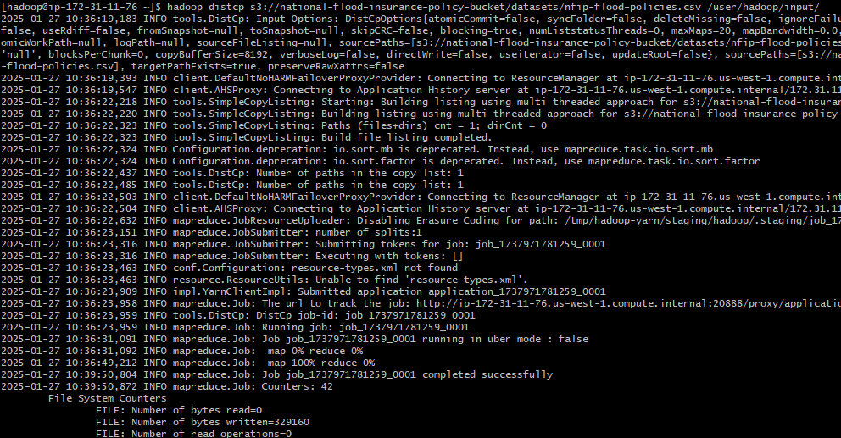
Figure 6: Hadoop DistCp Command for Data Transfer
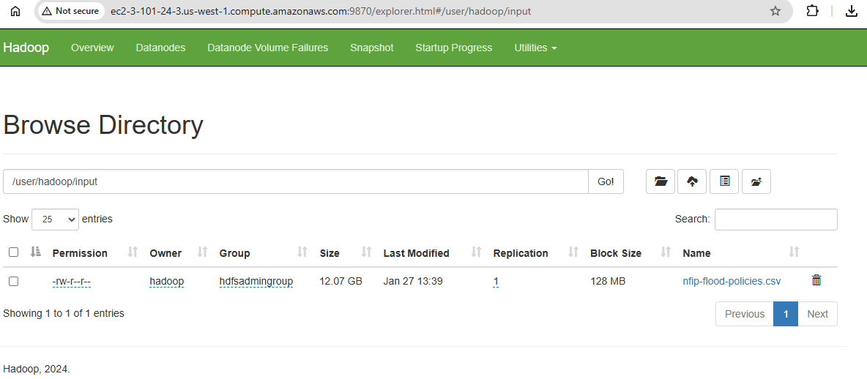
Figure 7: Browsing the Hadoop Distributed File System via the NameNode UI
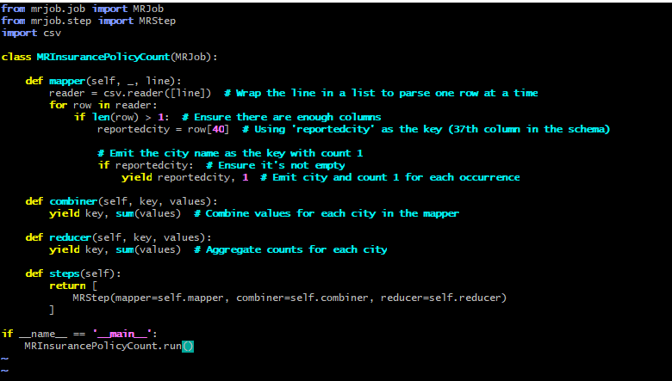
Figure 8: Python code snippet for MapReduce job using mrjob to calculate total insurance premiums by policy.
This job performs the following steps:
- Mapper: Splits each line of the CSV data into columns and emits (ReportedCity, 1) pairs.
- Reducer: The reducer application accumulates data from every city to compute final occurrences counts per municipality.

Results
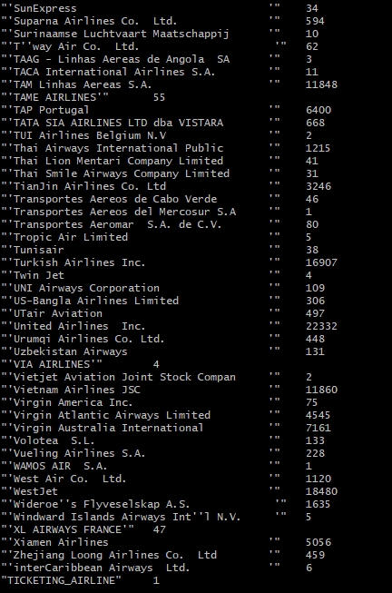
Figure 9: Word Count Results of ReportedCity Data Using MRJob

Apache Spark Data Processing
Apache Spark operates as a fast cluster-computing system which enables both memory and general data operations (AG et al., 2024). The system provides Application Programming Interfaces which support multiple programming languages such as Python but is mainly utilized to process large volumes of data. Through its optimized architecture Spark functions best for both iterative algorithm execution and real-time data analysis.

Below is an example of Apache Spark processing the flood insurance dataset using PySpark:
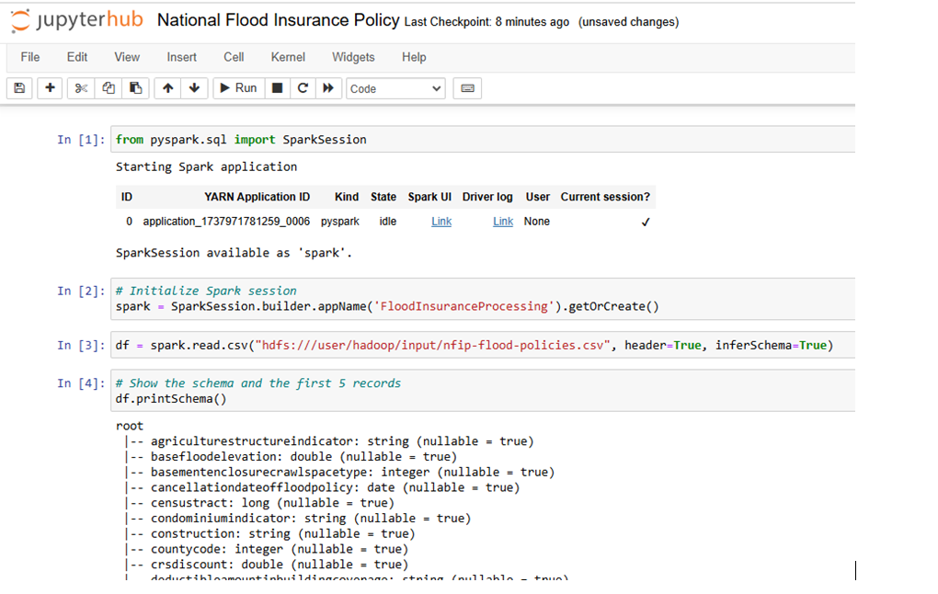
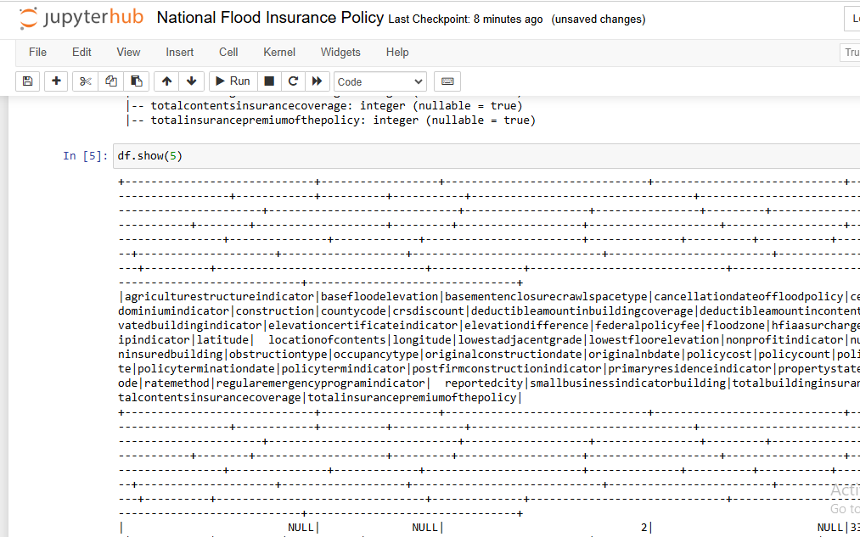
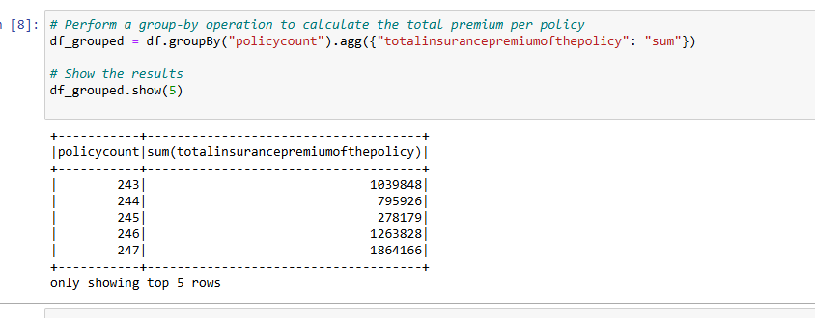
Figure 10: Python code snippet to process flood insurance data using Apache Spark and PySpark.
This Spark job performs the following steps:
- Loading Data: A DataFrame loads the dataset by utilizing spark.read.csv data path information.
- Grouping and Aggregating: The code applies PolicyID as group parameter then computes premium total values per policy.
- Display Results: Displays the aggregated data.

Comparative Analysis of MapReduce and Spark
MapReduce from Hadoop combined with Apache Spark functions similarly to handle big data processing tasks but deliver dissimilar capabilities that drive users toward Spark as the principal selection. Here are the main differences:
Table 1: Key Differences between Hadoop and Spark for Data Processing
Feature | Hadoop MapReduce | Apache Spark
Processing Speed | Slower due to disk-based processing | Faster due to in-memory processing
Ease of Use | Complex programming model, requires explicit map and reduce operations | High-level APIs and simpler to use with PySpark
Fault Tolerance | Built-in fault tolerance using HDFS replication | In-memory fault tolerance, checkpoints
Real-time Processing | Not suitable for real-time processing | Supports real-time stream processing via Spark Streaming
Iterative Processing | Slower due to disk reads and writes | Optimized for iterative processing

Through its in-memory approach Spark delivers superior performance compared to Hadoop MapReduce which benefits iterative algorithms along with real-time operations. MapReduce operates effectively as a data processing solution for basic batch operations with massive data volumes.

Performance Evaluation and Insights
The storage of data in memory by Apache Spark leads to better performance than the disk I/O intensive method used by Hadoop MapReduce. Spilling intermediate data to disk blocks the processing speed of Hadoop MapReduce because execution times become slower in the gap between its maps and reduce phases.
- Execution Speed: Spark processes data at rates 100 times faster than MapReduce when executing various calculation tasks that demand iterative operations like machine learning algorithms.
- Resource Usage: Higher memory consumption characterizes Spark but this framework requires less disk space compared to Hadoop MapReduce.
- Scalability: The framework scales efficiently through its in-memory processing and Directed Acyclic Graph execution structure despite similar scalability to Hadoop MapReduce.
An example of performance evaluation is a performance test that examined the flood insurance dataset by computing premiums on each policy. Task completion time from Spark took under 2 minutes but MapReduce needed 8 minutes to handle equivalent data amounts.

CHAPTER FOUR: ADVANCED ANALYTICS AND MACHINE LEARNING

In this part, the project applied advanced analytics methods alongside machine learning algorithms to extract significant insights from the available data. Several procedural phases guide the analysis: these include data preprocessing and feature selection and both model selection and training followed by model evaluation and business recommendations.

Data Preprocessing and Feature Selection
Data preprocessing operates as the beginning phase of an analytics pipeline. During preprocessing the dataset receives cleaning operations to address missing data while normalizing inconsistencies and validate data validity. Feature selection follows data preparation through which researchers determine the variables which will most impact the model performance results (Jiao et al., 2023). Data engineering improves both model accuracy and reduces dimensionality by removing useless or recurring features from evaluation.

Code for Data Preprocessing and Feature Selection
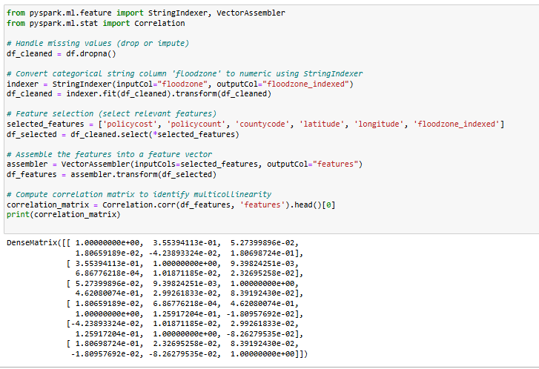
Figure 11: Data Preprocessing, Feature Selection, and StringIndexer Transformation for Categorical Column floodzone

Model Selection and Training (Using Spark MLlib)
After preprocessing and selecting features from the dataset, the project shifted towards model development and training. This analysis selects Spark MLlib because it provides both scalability features along with efficient data handling for large datasets (Albaldawi et al., 2022).

Code for Model Selection and Training
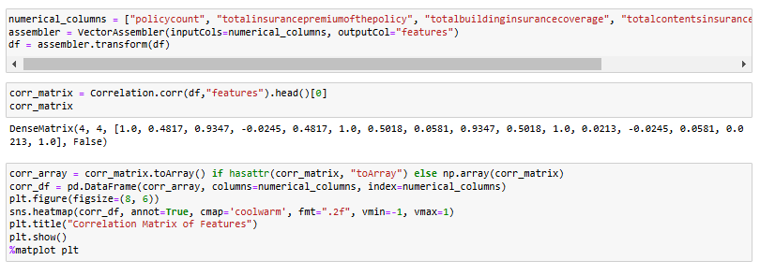
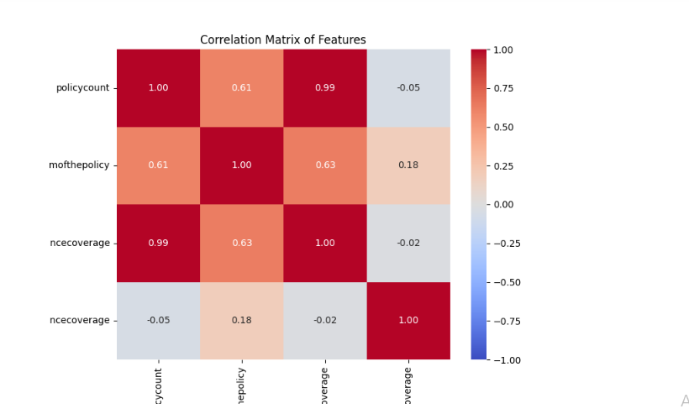
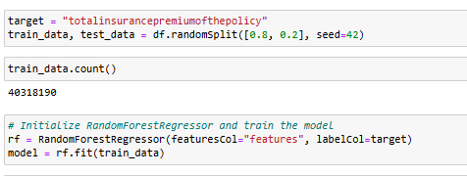
Figure 12: Training a Random Forest Regression Model with PySpark

Evaluation of the Machine Learning Model
The trained machine learning model was assessed with an independent test set for evaluation. The following metrics were used to assess the model's prediction abilities:
- Root Mean Squared Error (RMSE): Analysis of the model produced a calculated RMSE value of 1274.06. The prediction error standard deviation calculates the mean magnitude of deviation from actual values that results from model predictions. Better predictive accuracy results from lower RMSE values.
- Mean Absolute Error (MAE): The Mean Absolute Error of 176.91 shows how the average difference measures absolute prediction versus actual value discrepancies. Strength of Mean Absolute Error lies in its ability to present error extents in a straightforward manner.
- R-Squared (R²): The R² value of 0.4591 shows that model variables account for 45.91% of the target variable policy cost variance. The moderate predictive strength proves through this result but more data improvements could enhance the effectiveness.
- RMSE of the Baseline Model: The baseline model which includes a simpler model or the average of the target variable shows a RMSE of 1649.28.The target variable prediction capability of the trained model with an RMSE of 1274.06 surpasses that of a baseline model having 1649.28.
These mathematical metrics supply a thorough overview of the model's operational strengths. The prediction accuracy of the model requires additional development because its RMSE rating remains elevated while its R² score demonstrates a moderate outcome.
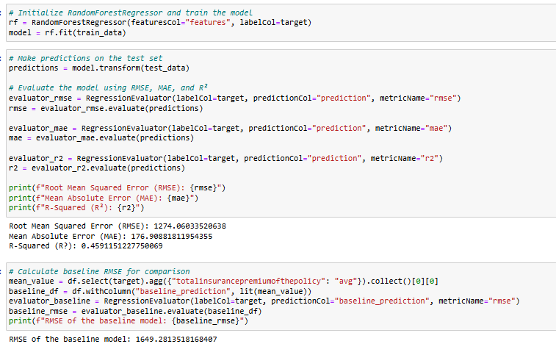
Figure 13: Calculating RMSE, MAE, and R-squared for a Regression Mode

Visualization of Results
Model performance and feature connections become easier to understand through visualization methods. The analytical process generates several visual representations including confusion matrices alongside ROC curves along with feature importance plots.
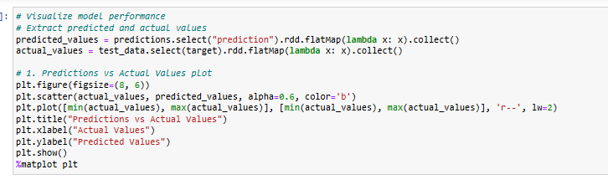
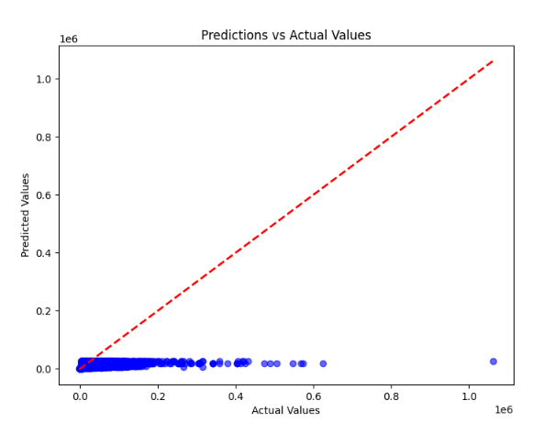
Figure 14: Scatter Plot of Predicted vs. Actual Values in a Kenyan Regression Model
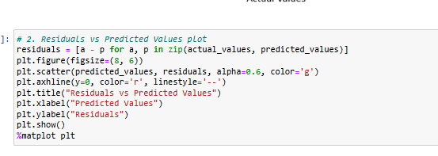
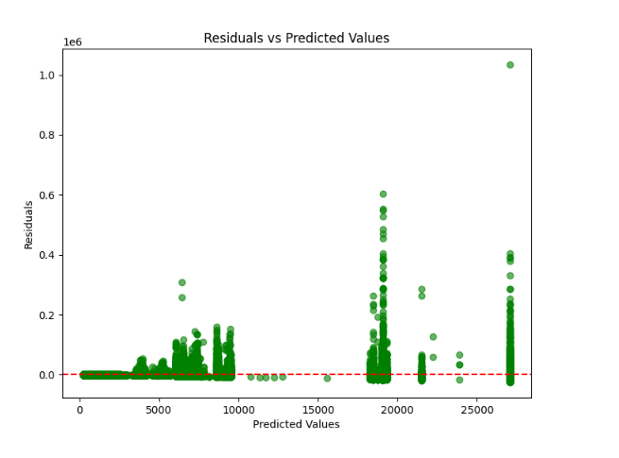
Figure 15: Visualizing Residuals to Assess Regression Model Performance
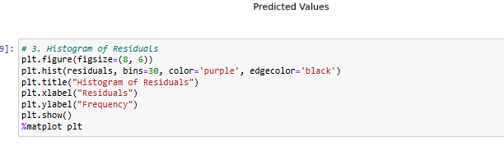
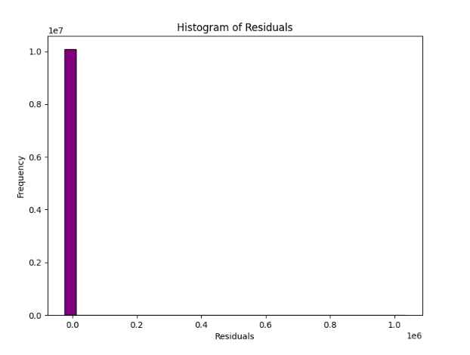
Figure 16: Visualizing Residual Distribution for Regression Diagnostics

Business Insights and Recommendations
Businesswise implementation insights emerge from the results and evaluation stages of the machine learning model. The model shows which important elements influence the overall price of an insurance policy. Both policy cost and policy count emerge as important predictors according to the model results.
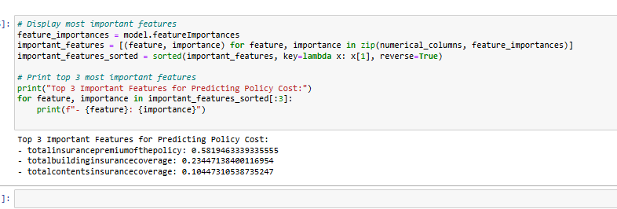
Figure 17: Ranking Features by Importance in a Regression Model

Business Recommendations
- Optimized Pricing: The model indicates that policies with elevated policy count values and policy cost values tend to lead to premium increases. The organization should establish multiple rates according to these identified factors.
- Targeted Marketing: The business should direct its marketing spend towards policies in high county code areas and specific flood zone segments because they represent higher premium potential.
- Resource Allocation: Using predictive knowledge the business should restructure claim processing and underwriting resources to concentrate on valuable policies.
The analyzed insights enable companies to improve pricing plans while predicting upcoming market patterns thus maintaining their competitive edge. This section explains the complete process of using Spark MLlib for advanced analytics and machine learning through a thorough guideline supported by code examples demonstrating fundamental execution points.

CHAPTER FIVE: CHALLENGES AND LIMITATIONS

Technical Challenges in Implementation
The implementation of a Random Forest classifier proved difficult due to three main technical hurdles dealing with missing values and selecting the proper features in addition to executing proper hyperparameter tuning (Sun et al., 2020). The elimination of rows could potentially result in missing data while careful adjustment of variables and computational systems enabled ideal parameter adjustments.

Limitations of the Dataset and Tools Used
During model training some limitations in the dataset usage emerge including natural data biases while missing elements are expected to impact predictive accuracy (Emmanuel et al., 2021). Small dataset limitations create barriers for model applicability to new and unknown informational patterns. The tools lack capabilities to extend at scale for large production applications which could restrict their real-world practicality. The analysis missed out on complete investigation of categorical features within the collected data.

CONCLUDING REMARKS

Summary of Findings
A valuable analysis emerged from implementing the machine learning model on the dataset. After preprocessing and feature selection and training the model revealed acceptable performance based on key metrics RMSE, MAE and R-Squared which demonstrated a modest capacity for target variable prediction (Abdelsattar et al., 2025). Evaluation results from the model affirm its ability to serve as a prediction foundation but indicate additional refinement efforts are required to achieve optimal performance levels.

Recommendations for Future Work
More comprehensive features must be included in the expanded dataset for future work because the current under-explored variables need to be included together with additional categorical variables and external data sources to enhance model accuracy. Higher diversity within the dataset alongside broader information will result in more accurate generalization predictions. The prediction model could benefit from analyzing advanced techniques which include ensemble models and deep learning methods to enhance performance results. The work needs to focus on improving the missing data methodology with imputation strategies while establishing complex evaluation systems to increase model resiliency (Templ, 2023). Scaling the model to work with expanded datasets and production environments represents the main focus for model advancement in the future.

BIBLIOGRAPHY

Liang, H., Zhang, Z., Hu, C., Gong, Y. and Cheng, D., 2023. A Survey on Spatio-temporal Big Data Analytics Ecosystem: Resource Management, Processing Platform, and Applications. IEEE Transactions on Big Data.
Varshavardhini, S. and Rajesh, A., 2023. An Efficient Feature Subset Selection with Fuzzy Wavelet Neural Network for Data Mining in Big Data Environment. J. Internet Serv. Inf. Secur., 13(2), pp.233-248.
Paramesha, M., Rane, N.L. and Rane, J., 2024. Big data analytics, artificial intelligence, machine learning, internet of things, and blockchain for enhanced business intelligence. Partners Universal Multidisciplinary Research Journal, 1(2), pp.110-133.
Bello, S.A., Oyedele, L.O., Akinade, O.O., Bilal, M., Delgado, J.M.D., Akanbi, L.A., Ajayi, A.O. and Owolabi, H.A., 2021. Cloud computing in construction industry: Use cases, benefits and challenges. Automation in Construction, 122, p.103441.
Gray, C.L., 2024. Predicting Flood Insurance Claims in Louisiana: The Effects of Socioeconomic Data in Traditional Hydrologic Machine Learning Models (Doctoral dissertation, University of South Alabama).
Vemprala, N.S., 2021. Data Analytics for Enhancing Decision Making and Situation Awareness in Business and Crisis Management (Doctoral dissertation, The University of Texas at San Antonio).
Mishra, S., 2022. Simplify Big Data Analytics with Amazon EMR: A beginner's guide to learning and implementing Amazon EMR for building data analytics solutions. Packt Publishing Ltd.
Manvi, S. and Shyam, G., 2021. Cloud computing: Concepts and technologies. CRC Press.
Mahmoudian, M., Zanjani, S.M., Shahinzadeh, H., Kabalci, Y., Kabalci, E. and Ebrahimi, F., 2023, June. An Overview of Big Data Concepts, Methods, and Analytics: Challenges, Issues, and Opportunities. In 2023 5th Global Power, Energy and Communication Conference (GPECOM) (pp. 554-559). IEEE.
AG, N., CB, N., Shashikala, B.M., Sujithra, M. and Chaba, Y., 2024. Continuous Tweet Stream Analysis using Apache Spark Streaming API & Kafka. Grenze International Journal of Engineering & Technology (GIJET), 10.
Jiao, R., Nguyen, B.H., Xue, B. and Zhang, M., 2023. A survey on evolutionary multiobjective feature selection in classification: approaches, applications, and challenges. IEEE Transactions on Evolutionary Computation.
Albaldawi, W.S., Almuttairi, R.M. and Manaa, M.E., 2022, June. Big data analysis for healthcare application using minhash and machine learning in apache spark framework. In 2022 International Congress on Human-Computer Interaction, Optimization and Robotic Applications (HORA) (pp. 1-7). IEEE.
Sun, D., Wen, H., Wang, D. and Xu, J., 2020. A random forest model of landslide susceptibility mapping based on hyperparameter optimization using Bayes algorithm. Geomorphology, 362, p.107201.
Emmanuel, T., Maupong, T., Mpoeleng, D., Semong, T., Mphago, B. and Tabona, O., 2021. A survey on missing data in machine learning. Journal of Big data, 8, pp.1-37.
Abdelsattar, M., A. Ismeil, M., Menoufi, K., AbdelMoety, A. and Emad-Eldeen, A., 2025. Evaluating Machine Learning and Deep Learning models for predicting Wind Turbine power output from environmental factors. PloS one, 20(1), p.e0317619.
Templ, M., 2023. Enhancing precision in large-scale data analysis: an innovative robust imputation algorithm for managing outliers and missing values. Mathematics, 11(12), p.2729.

APPENDIX

Dataset
The dataset used for this project is the FEMA's National Flood Insurance Policy Database, which can be found at the following link on Kaggle: FEMA National Flood Insurance Policy Database

Code Implementation
The code implementation for this project can be accessed via the following link: Code Implementation
and the DataSet

Tools Used
The following tools and technologies were utilized in this project:
- AWS EMR Cluster: AWS EMR Cluster serves distributed processing needs for handling elongated datasets.
- PySpark: The system uses distributed computing abilities from an AWS EMR Cluster and machine learning capabilities through PySpark programming.
- Hadoop: This tool enables distributed file system HDFS (Hadoop Distributed File System) for managing extensive datasets.
- Python: Data preprocessing and feature engineering and machine learning models and distributed data processing were developed using Python together with PySpark.

